RoundTable Presentation Outline:

Nandita Kohli

Idea 1:

* Pull article data from different news outlets
* Count how many times key words and phrases are used such as “Trump”, “Make America Great Again”, “Allegations”, etc.
* Make a list of about 20 words to track
  + Tentative:
    - Trump
    - Make America Great Again
    - MAGA
    - Putin
    - Allegations
    - Vote
    - Elections
    - Campaign
    - scandal
    - twitter
    - GOP
    - Democrats
    - Democracy
    - National security
    - Shooting
    - Deal
    - Business
    - Gerrymandering
    - Politicize
    - Fake news
* Change the size of the word based on the number of times it is used
* Have words floating on page
* Have it rotate through different news outlets (maybe around 3 different news stations)
  + MSNBC
  + CNN
  + FOX
* Color and font change each time news station changes?
* Maybe incorporate different years?
* Tools
  + Google Developer on Data Charts: <https://developers.google.com/chart/interactive/docs/basic_interactivity>
* Research
  + <https://www.cnn.com/2018/11/13/media/cnn-sues-trump/index.html>
  + <http://www.msnbc.com/topics/donald-trump>
  + <https://www.foxnews.com/entertainment/cnn-files-lawsuit-against-trump-administration-to-restore-jim-acostas-white-house-credential>
  + CNN API: <https://newsapi.org/s/cnn-api>
  + MSNBC API: <https://newsapi.org/s/msnbc-api>
  + Fox News API: <https://newsapi.org/s/fox-news-api>
* Inspiration
  + Jer Thorp
    - <https://www.jerthorp.com/exo>
  + How America Runs: <https://flowingdata.com/2015/12/15/a-day-in-the-life-of-americans/>
  + On Flowing Data: <https://medium.com/@EvanSinar/use-animation-to-supercharge-data-visualization-cd905a882ad4>

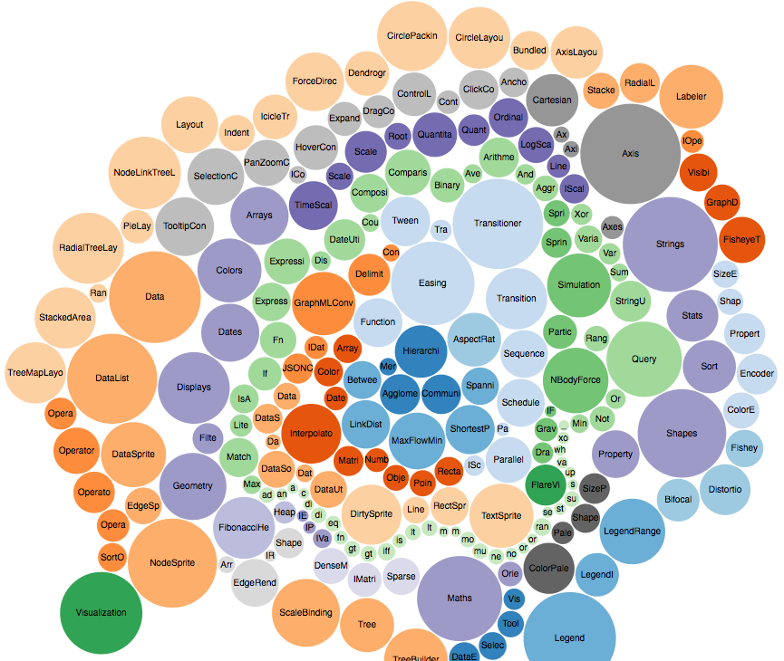 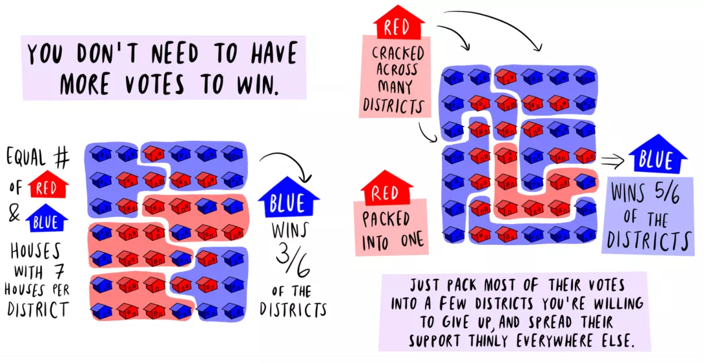

Idea 2:

* Create image / map with input
* Each time a person inputs a country or place map draws a line from here (NY) to place
* Creates a web of places you’ve traveled
* Inspiration:
  + Thought Cafe work: <https://vimeo.com/213745202>
  + Jer Thorp: <https://vimeo.com/4587178>
  + Animated European History Map: <http://www.visualcapitalist.com/2400-years-of-european-history/>
  + Flight Maps Article gifs: <http://metrocosm.com/globe-air-traffic-particles/>
  + After effects template:<https://www.youtube.com/watch?v=IdkSar74c2k>

Idea 3:

* Found poetry - find different poems inside of poems?
* Body shape? Shapes you make with mouse?
* 3D Shapes already embedded?
* Maybe based on click, show certain poem
* Inspiration
  + Yoon Chung Han Eye: <http://codame.com/projects/eyes>
    - Combined bio and art and music to show discovery of self
    - Combine shapes and poetry to discover self
  + Jer Thorp
    - <https://www.jerthorp.com/salesman>
  + Artechouse: fall into a poem:

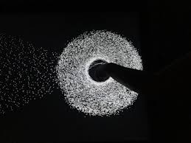 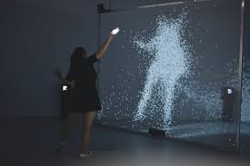

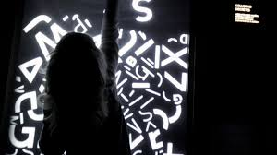

Idea 4:

* Create a data picture
* Landscape of a place with animation
* Numbers and statistics on everything about said thing
* User interactivity -- when click goes inside…
* Perhaps use 5 different screens
* Perhaps Shenandoah? Or NYC? Or NYU? Or Tandon?
* Perhaps do overtime?
* Inspiration
  + John Green Theme Songs: <https://www.youtube.com/watch?v=TcGnst1qnsQ>
  + Thought Cafe work: <https://vimeo.com/213745202>
  + Word World: <https://www.youtube.com/watch?v=nmtsFnCYDHc>
  + Congaz: <http://www.congaz.de/film-animation/project/wacom-internet-of-ink-ifa-2016/>

